myWIC Accessibility Guide
Accessibility is the practice of designing and developing websites, applications, and other digital products that can be used by everyone, including people with disabilities. Accessibility ensures that all users have equal access to information, functionality, and services. myWIC strives to follow the Web Content Accessibility Guidelines (WCAG) 2.1, which are internationally recognized standards for web accessibility.

Contents
Reference & Tooling 2
Specification 2
Resources 2
Tools/Testing 2
Best Practices 2
Semantic Elements 2
Examples 2
Keyboard Navigation 3
Examples 3
Screen Reader Support 4
Tappable Area (Mobile) 4
Examples 4

Reference & Tooling

Specification
- Web Content Accessibility Guidelines (WCAG) 2.1 (w3.org)

Resources
- Introduction to accessibility testing (sharepoint.com) – Microsoft
- Screen Reader Fundamentals - Microsoft

Tools/Testing
- Accessibility Insights for Web - Microsoft Edge Addons
- Accessibility Insights for Azure DevOps (Future)

Best Practices

Semantic Elements
Semantic elements are HTML tags that convey the meaning and structure of the content, rather than just the presentation. These are useful for screen readers on web and mobile.

Examples
- accessibilityRole Property on Text elements
  - This allows us to render a specific element instead of just basic text
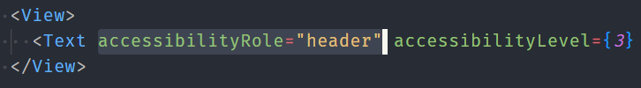
- accessibilityLevel Property on Text elements
  - This allows us to render a specific header level (h1,h2,h3,h4,h5,h6)
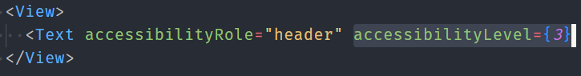

Keyboard Navigation
Keyboard navigation is important for accessibility because it allows users who have difficulty using a mouse or other pointing device to navigate the web content using only their keyboard. Keyboard navigation also benefits users who rely on screen readers, braille keyboards, or other assistive technologies that interact with the web through the keyboard.

Examples
- Element Outline - Elements are highlighted when tabbing through content
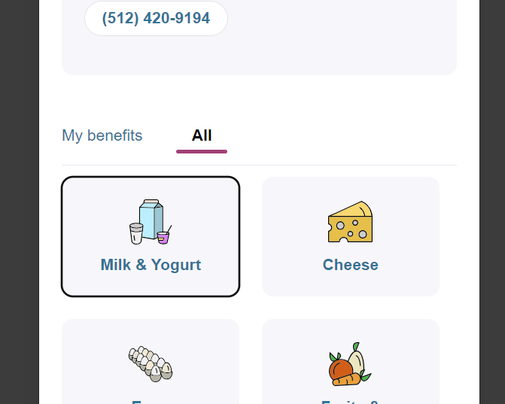
Milk & Yogurl selected by Tab key
- Tab Order – Proper tab order ensures meaningful navigation for a keyboard user.
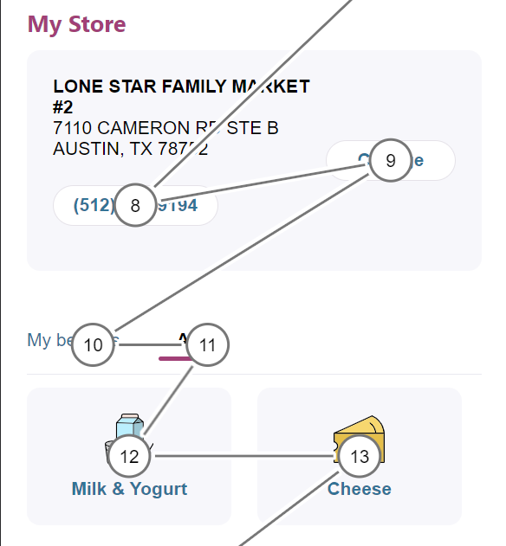
Visualized tab order with help of Accessibily Insignts
- Skip to Main Content Button – This allows keyboard / screen reader users to bypass unwanted elements (i.e. navigation menus) to get to the main content
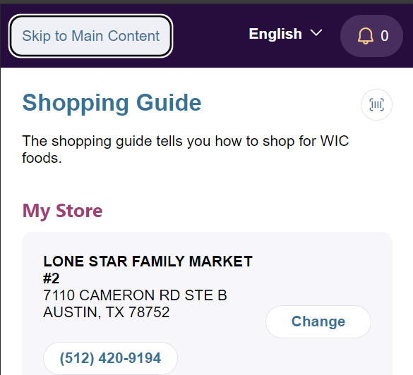
Skip to Main Content button appears after pressing tab

Screen Reader Support
Screen reader support is essential for making websites accessible to people who are blind or have low vision. Screen readers are software applications that convert text and other elements on the screen into speech or braille output. Proper Keyboard Navigation and Tab Order will help screen readers navigate the application.

Tappable Area (Mobile)
Tappable area refers to the size and shape of the touch targets on a mobile screen. Touch targets are the areas that respond to the user's taps, swipes, or other gestures. Having a sufficient tappable area is important for accessibility because it ensures that users with different finger sizes, hand positions, or motor impairments can easily interact with the app. If the tappable area is too small or too close to other elements, users may accidentally activate the wrong target or have difficulty activating any target at all.

Examples
- hitSlop Property – This property enables us to specify a large tappable area for smaller items.
